Great Lakes Bottomlands and Coastal Wetlands Restoration
(North Maumee Bay, Michigan)

Project: Through the demonstration of innovative, sustainable techniques for bottomlands restoration on approximately 100 acres adjacent to Erie Marsh Preserve this project will:
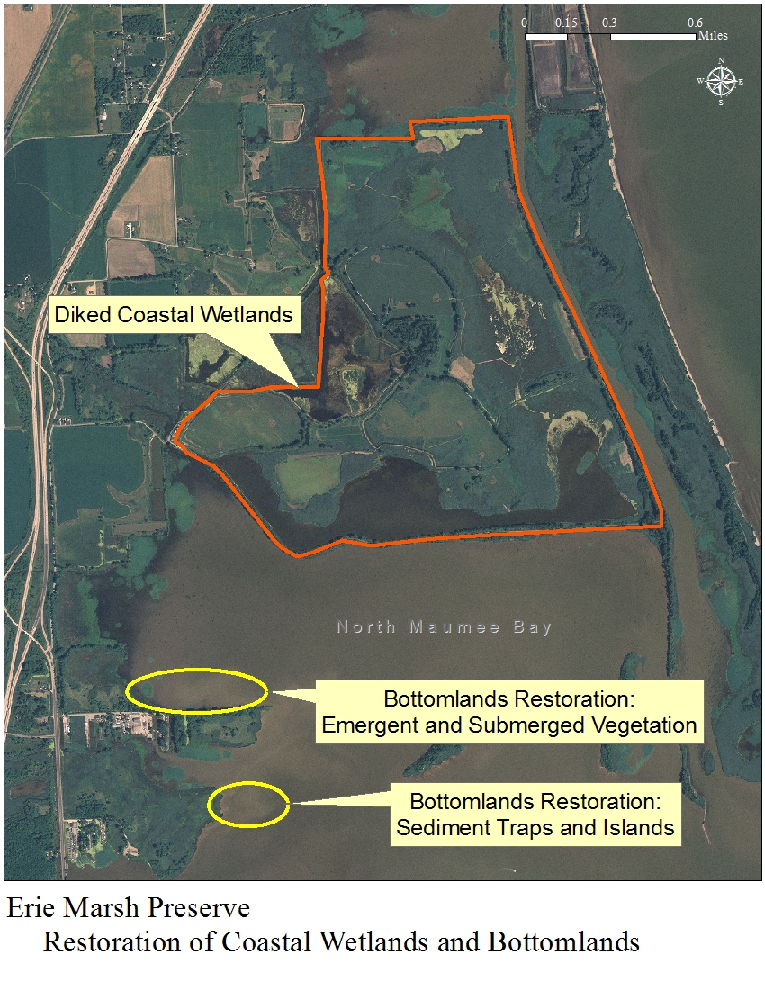
- Reduce shoreline hardening
- Reduce stress on formerly productive submerged wetlands
- Improve the condition of a 4,000-acre embayment

Link overarching WLEB strategies:
- Implement innovative and resilient on-the-ground habitat restoration projects
TNC’s Erie Marsh Preserve. The area bound in red indicates where wetland restoration is happening. The yellow circles indicate sites for proposed bottomlands restoration.
- Integrate ecological and human well-being values to create a shared vision, engaging a broad spectrum of public and private interests
- Direct restoration investments and inform management decisions

Project summary: Over the past 150 years heavy industrialization and urbanization of the Western Lake Erie watershed, along with the construction of dams on major rivers for flood control and hydroelectric power, has altered coastal wetlands and processes in and around North Maumee Bay. Changes include increased amounts and rates of sediments flowing into the lake, modification of the patterns of nearshore currents, and interrupted longshore transport patterns of sand.

Fluctuating lake levels and sediment distribution patterns have also altered patterns of erosion and deposition. These changes will likely be made worse by climate change, which is expected to cause more unpredictable lake-level fluctuations in the Great Lakes and is altering water temperatures and wind and wave patterns.

Historically, to deal with these stressors, managers constructed dikes around most of the wetlands in Western Lake Erie, and installed water management systems to control water levels to suit management needs. Without these “managed” systems, the coastal wetland area within the perimeter dikes would become open water habitat similar to the rest of North Maumee Bay as the perimeter dikes erode and ultimately fail.

Therefore, in order to achieve a more sustainable, resilient coastal wetland system, The Nature Conservancy has developed a pilot project design for innovative, adaptable lakebed restoration that will be “climate smart” by providing a means to counteract fluctuations in lake levels and future drought conditions. The project will re-establish historical landforms and wetlands that will help to improve the water quality and reduce turbidity in North Maumee Bay. Implementing such a plan will involve:
- Sedimentation traps and barriers to create a peninsula of land that will protect a portion of the northern bay from turbidity, thereby improving water quality
- Establishing emergent and submerged vegetation through the use of sediment islands and floating islands of vegetation

This pilot project will also serve as a means to assess the feasibility of several strategies for rehabilitation of coastal wetlands in other portions of North Maumee Bay and the Great Lakes.
Key partners:
- Michigan Department of Environmental Quality
- Michigan Department of Natural Resources
- U.S. Army Corps of Engineers
- Consumers Energy
- Environmental Consulting & Technology, Inc.
Project timeframe:
- Coastal engineering analysis of site-specific conditions, 2013-2014
- Restoration to commence pending completion of engineering analysis, consultation with MDEQ on permitting feasibility, and the necessary funding is secured.

